Veterans Business Outreach Center  Partner Authorization Form | 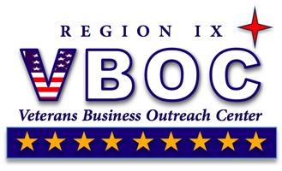

Date

I, Name of Authorizing Person, authorize the Veterans Business Outreach Center (VBOC) to release confidential personal and business information to Name of Partner Receiving Authorization and receive small business consulting services on behalf Name of Authorizing Person/Company Name.

This authorization is for the sole purpose of starting, sustaining or expanding a small business initiative.

In conclusion, I hereby understand and acknowledge the aforementioned individual may receive and share personal and business information with VBOC Administrations and VBOC Business consultants.

Print Name |  |  |  | Date
Print Name of Authorizing Person |  | Signature of Authorizing Person |  | Date

